SIMATS ENGINEERING
ASSESSMENT TOOL 2
COURSE NAME: Fundamentals of Data Science
COURSE CODE: DSA04
COURSE OUTCOME COVERED
CO4: Develop machine learning models for classification, regression, and clustering, including performance evaluation and methodology comparison. (BL3)
Assessment Tool Weightage: 30%
QUESTIONS: 01
Total Marks:100
Annexure A
Industry Problem Solving

Code of Conduct:
I Valli Karthik (192324258) certify that this submission is my original work and that I have adhered to the guidelines specified for this assessment.
I understand that any violation of academic integrity rules will result in disciplinary action.
Signature of the student:


RUBRICS FOR CALCULATION
SCENARIO BASED ASSESSMENT
Criteria | Weightage  (%) | Level 4  (Exemplary) | Level 3  (Proficient) | Level 2  (Developing) | Level 1  (Beginning) | Level | Marks
Understanding of Scenario | 20% | Demonstrates clear and complete  understanding of the scenario and  context | Shows good  understanding  with minor gaps | Partial  understanding;  misses key  aspects | Misinterprets or fails to  understand the scenario
Identification of Key Issues | 20% | Accurately  identifies all  relevant issues and factors involved | Identifies most  key issues with minor omissions | Identifies limited issues; some  irrelevant points | Unable to  identify key  issues
Application of Concepts | 25% | Applies appropriate concepts effectively to address the  scenario | Applies concepts with minor errors | Limited or  partially correct application | Unable to apply relevant  concepts
Decision  Making | 20% | Makes well  reasoned, logical decisions with  strong rationale | Makes  reasonable  decisions with  some  justification | Makes weak  decisions with  limited  justification | No clear  decisions made or rationale  provided
Clarity of  Response | 15% | Response is clear, structured, and  logically presented | Generally clear with minor issues | Somewhat unclear or poorly  structured | Disorganized  and difficult to understand

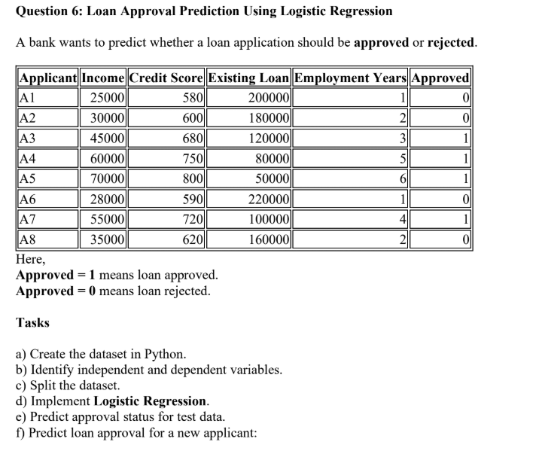
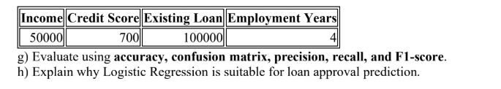

1. Scenario Understanding and Objective
A bank wants to predict whether a loan application should be approved or rejected using applicant financial and employment information. The target is binary: Approved = 1 (approved) and Approved = 0 (rejected).
Objective: build a Logistic Regression classification model, predict the test samples and a new applicant, evaluate the model using the required classification metrics, and interpret the result for the banking scenario.

2. Task (a): Dataset Creation
The dataset contains eight loan applications and four independent variables.
Applicant | Income | Credit Score | Existing Loan | Employment Years | Approved
A1 | 25,000 | 580 | 200,000 | 1 | 0
A2 | 30,000 | 600 | 180,000 | 2 | 0
A3 | 45,000 | 680 | 120,000 | 3 | 1
A4 | 60,000 | 750 | 80,000 | 5 | 1
A5 | 70,000 | 800 | 50,000 | 6 | 1
A6 | 28,000 | 590 | 220,000 | 1 | 0
A7 | 55,000 | 720 | 100,000 | 4 | 1
A8 | 35,000 | 620 | 160,000 | 2 | 0
Python implementation is provided in the source file accompanying this report.

3. Task (b): Independent and Dependent Variables
Type | Variable | Description
Independent (X) | Income | Applicant income
Independent (X) | CreditScore | Applicant credit score
Independent (X) | ExistingLoan | Existing loan amount
Independent (X) | EmploymentYears | Years of employment
Dependent (y) | Approved | 1 = approved, 0 = rejected
Independent variables: X = [Income, CreditScore, ExistingLoan, EmploymentYears]. Dependent variable: y = Approved.
4. Task (c): Train-Test Split
The dataset is split into 75% training data and 25% testing data. random_state=42 makes the split reproducible, while stratify=y preserves the class distribution as far as possible.
Set | Applicants | Number of Records
Training | A3, A2, A4, A7, A1, A8 | 6
Testing | A6, A5 | 2

5. Task (d): Logistic Regression
Logistic Regression is trained on the six training observations. The model estimates the probability of the binary target and assigns a class based on the learned decision boundary.
Model: LogisticRegression(max_iter=1000)

6. Task (e): Test Data Prediction
Applicant | Actual | Predicted | Result
A6 | 0 (Rejected) | 0 (Rejected) | Correct
A5 | 1 (Approved) | 1 (Approved) | Correct
The model correctly classifies both test records.

7. Task (f): New Applicant Prediction
Feature | New Applicant
Income | 50,000
Credit Score | 700
Existing Loan | 100,000
Employment Years | 4
Predicted class: 1 — LOAN APPROVED.
The model's predicted probability for approval is approximately 1.0000 on this fitted model. Because the training dataset is extremely small, this probability should not be interpreted as a reliable real-world risk probability.
8. Task (g): Model Evaluation
Metric | Value | Interpretation
Accuracy | 1.00 (100%) | 2 out of 2 test samples were classified correctly.
Confusion Matrix | [[1, 0], [0, 1]] | 1 true negative, 1 true positive, no false positives or false negatives.
Precision | 1.00 (100%) | All samples predicted as approved were actually approved.
Recall | 1.00 (100%) | All actual approved samples in the test set were identified.
F1-Score | 1.00 (100%) | Precision and recall are both 1.00.
Confusion matrix layout: [[TN, FP], [FN, TP]]. Therefore TN = 1, FP = 0, FN = 0, TP = 1.

9. Task (h): Why Logistic Regression is Suitable
- The target variable has two classes: approved (1) and rejected (0), which is a binary classification problem.
- Logistic Regression directly estimates the probability of class membership.
- The model is computationally efficient and relatively easy to interpret.
- The model can provide both a predicted class and a probability, which is useful for decision-support systems.
- It provides a strong baseline model for banking classification before considering more complex algorithms.

10. Complete Python Program

import pandas as pd
from sklearn.model_selection import train_test_split
from sklearn.linear_model import LogisticRegression
from sklearn.metrics import (
accuracy_score, confusion_matrix,
precision_score, recall_score, f1_score
)
# 1. Create the dataset
data = {
"Applicant": ["A1", "A2", "A3", "A4", "A5", "A6", "A7", "A8"],
"Income": [25000, 30000, 45000, 60000, 70000, 28000, 55000, 35000],
"CreditScore": [580, 600, 680, 750, 800, 590, 720, 620],
"ExistingLoan": [200000, 180000, 120000, 80000, 50000, 220000, 100000, 160000],
"EmploymentYears": [1, 2, 3, 5, 6, 1, 4, 2],
"Approved": [0, 0, 1, 1, 1, 0, 1, 0]
}
df = pd.DataFrame(data)
print("DATASET")
print(df)
# 2. Identify independent and dependent variables
X = df[["Income", "CreditScore", "ExistingLoan", "EmploymentYears"]]
y = df["Approved"]
# 3. Split the dataset: 75% training, 25% testing
X_train, X_test, y_train, y_test = train_test_split(
X, y, test_size=0.25, random_state=42, stratify=y
)
print("\nTraining rows:", X_train.index.tolist())
print("Testing rows:", X_test.index.tolist())
# 4. Implement Logistic Regression
model = LogisticRegression(max_iter=1000)
model.fit(X_train, y_train)
# 5. Predict approval status for test data
y_pred = model.predict(X_test)
print("\nActual test values:", y_test.values)
print("Predicted test values:", y_pred)
# 6. Predict the new applicant
new_applicant = pd.DataFrame(
[[50000, 700, 100000, 4]],
columns=["Income", "CreditScore", "ExistingLoan", "EmploymentYears"]
)
new_prediction = model.predict(new_applicant)
new_probability = model.predict_proba(new_applicant)
print("\nNew applicant prediction:")
print("Status:", "Approved" if new_prediction[0] == 1 else "Rejected")
print("Probability of rejection:", new_probability[0][0])
print("Probability of approval:", new_probability[0][1])
# 7. Evaluate the model
accuracy = accuracy_score(y_test, y_pred)
cm = confusion_matrix(y_test, y_pred)
precision = precision_score(y_test, y_pred)
recall = recall_score(y_test, y_pred)
f1 = f1_score(y_test, y_pred)
print("\nMODEL EVALUATION")
print("Accuracy:", accuracy)
print("Confusion Matrix:\n", cm)
print("Precision:", precision)
print("Recall:", recall)
print("F1-Score:", f1)

Output:
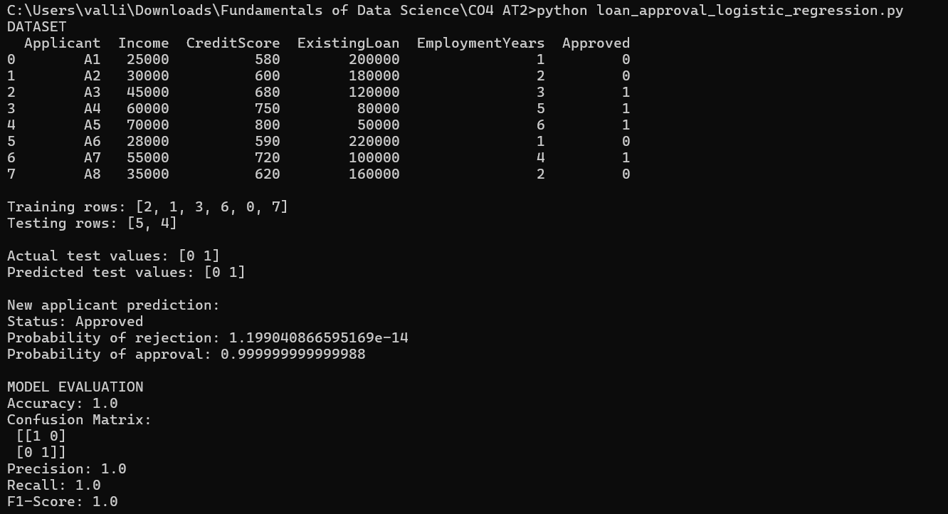
11. Interpretation and Decision Making
The model produced correct predictions for both observations in the selected test set. It also predicts that the new applicant (income 50,000, credit score 700, existing loan 100,000 and four employment years) should be approved.
From a banking decision-support perspective, the applicant has a comparatively stronger profile than the rejected examples in the given dataset: the credit score is higher, income is higher than several rejected applicants, and the existing loan amount is lower than several rejected applicants.
However, the result must be treated cautiously. The dataset has only eight observations and the test set contains only two observations. A 100% score on such a tiny test set does not demonstrate that the model will generalize to real customers. A real banking system should use a much larger, representative dataset and should validate the model using additional samples or cross-validation.

12. Key Issues and Limitations
- Very small dataset: only 8 observations are available.
- Very small test set: only 2 observations are used for evaluation.
- The variables are limited and do not represent all real loan-approval factors.
- The model should not be deployed for actual lending decisions without broader validation, fairness checks and domain review.
- The reported 100% metrics are specific to this selected train-test split.

13. Conclusion
Logistic Regression was successfully implemented for binary loan approval classification. The model achieved 100% accuracy, precision, recall and F1-score on the selected test split, with a confusion matrix of [[1, 0], [0, 1]]. The new applicant was predicted as approved. Logistic Regression is appropriate because the outcome is binary and the method provides an interpretable probability-based classification approach. Nevertheless, the extremely small dataset means the reported performance should be considered illustrative rather than evidence of production-level accuracy.

